EXERCISE NUMBER:4
DATE:14/10/2020
Aim: To swap first two character from the given two strings
Program:
def convert(s):
new=""
for x in s:
new+=x
return new
a=input()
b=input()
s1=a.strip()
s2=b.strip()
if(len(s1)>=2 and len(s2)>=2):
t1=list(s1)
t2=list(s2)
c1=t1[0]
c2=t1[1]
t1[0]=t2[0]
t1[1]=t2[1]
t2[0]=c1
t2[1]=c2
s1=convert(t1)
s2=convert(t2)
print(s1," ",s2)
else:
print("Invalid")

Link:http://103.53.53.18/mod/vpl/forms/submissionview.php?id=234&userid=1746

Output:

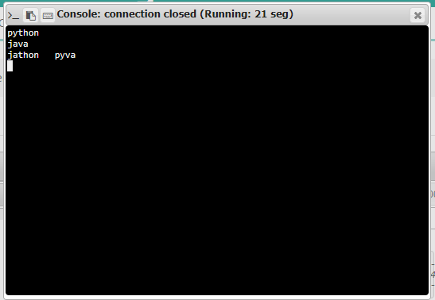
RESULT: The output of this program is verified.

